**PROJECT REPORT**

**ON**

**“WEB-APPLICATION USING DJANGO IN PYTHON”**

**PRESENTED**

**BY**

**AYAZ SAYYAD**

**SHAIKH IMRAN SADEKH**

**REPORTED TO**

**MUDDASSIR SHAIKH**

**Abstract of the Project:**

**About Django**

It was created in the yr of 2003 and 2005 by web team who were responsible for creating newspaper websites.

Django is a high-level python web framework use do devlop web pages and it take care of much hassle of web development.it provide secure way to manage user name and pwd.it used cryptographic function.

Django is opiniated. (opinions about right way)

It supports four types of database Postgress SQl, MysQl, Oracle, SqLite.

It follows MVC architecture.

**Feature of Django**

* Complete
* Versatile
* Secure
* Scalable
* Maintainable
* Portable

**Working Environment of Django**

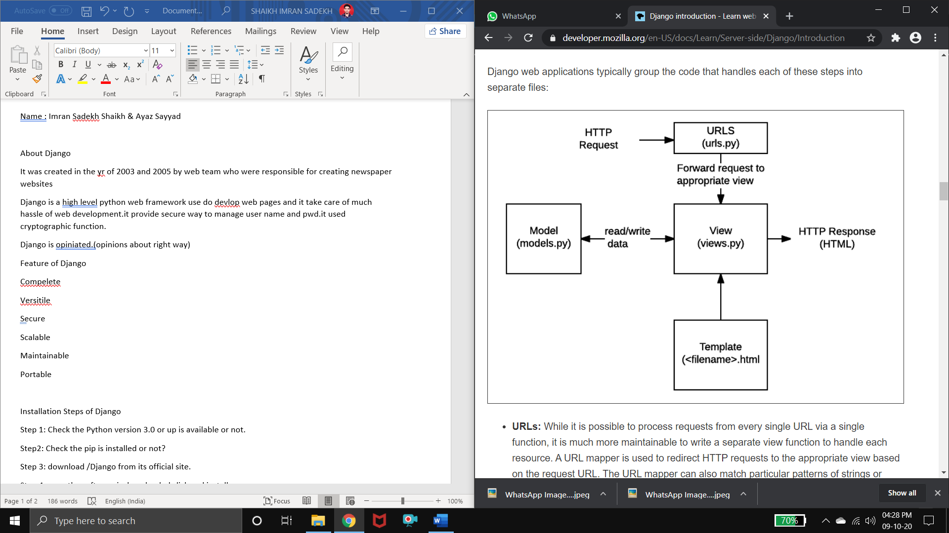

* **URLS:** more maintainable to write seprate view function to handle each resource.url mapper is used to redirect http request.to the appropriate view.
* **View:** a view request handlers function which receives http request and return http response.
* **Models:** this are python object define the structure of application.
* **Template:** text file defines the structure of file.

**Installation Steps of Django**

**Step 1:** Check the Python version 3.0 or up is available or not.

**Step2:** Check the pip is installed or not?

**Step 3:** download /Django from its official site.

**Step 4:** once the software is downloaded click and install.

**Step5:** Select 1st option and copy the code.

>> pip install Django==3.1.2

Then click on enter button.

Installed from source from Python Package index (PyPi) in many case from the host computers package mangers application.

**Verifying Django Installation**

**Step 1:** Opne the pythin on command prompt

**Step 2:** type following command

>> Import Django

**Note:** when Django is not install then it show error >> modulenotfoundError : no module name Django

**Step 3:** type on cmd for checking Django version.

>>print(Django.get_version())

**REFERENCES**

1] https://developer.mozilla.org/en-US/docs/Learn/Server-side/Django/Introduction